Notes on Trout Lake QA/QC for Catchment metabolism project
Notes below by Jen Klug on 2/16/16, 2/29/16,3/1/16
Using files generated by Jake (see below)
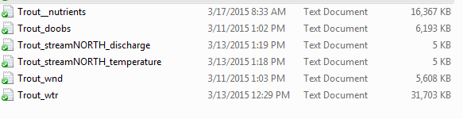
Still need PAR data and stream nutrient data
Buoy data file in dropbox ha s par column but it is empty
Trout lake discharge data was gathered from http://climhy.lternet.edu/plot.pl

METADATA – no metadata in metadata file as of 2/16/16
Trout DO sensor depth = 0.5 m (as per LTER website)
atmPres <- #average atmospheric pressure at local elevation, mmHg
windHeight <- 2m (as per Tim Meinke) #height above lake at which wind speed is meaured
timeStep <- 1 #number of minutes between DO measurements
lat<- #latitude of Trout Lake

DO file
Missing data 7/15/13 to 7/17/13. Intermittent missing data on other days in July.
Missing data 7/22-7/26 (with partial day on 7/24)
Missing rows 10/23-10/27 and 11/1-11/5 – added with NA
No obvious outliers or abnormalities
Wind file
Removed 2 outliers – 2 data points ~30 m/s (~70 mph) – 7/11/13 7:33 and 10/12/13 18:07
Quite a few missing values (partial hours) throughout the summer.
Missing rows 10/23-10/27 and 11/1-11/5 – added with NA
Temperature profile data
Missing data 6/12/13 to 6/14/13
Missing data 7/15/13 to 7/17/13.
Missing data 7/22-7/26
Missing data from bottom 6 sensors (20,22,24,26,28,30) from 6/12/13 to end of summer
- Deleted these sensors for whole summer
Quite a few missing values (partial hours) throughout the summer.
Missing rows 10/23-10/27 and 11/1-11/5 – – added with NA
Looked at min/max – some pretty high values for Trout (35 at surface) - corresponds with notes below
Depth 0 – odd behavior (temp range 9-35 in late July) 7/26-8/2 start of bad data starts with end of 4 day missing data for whole string. See below. Y is temp at Depth 0. Data from depth 1 looks nothing like this. Deleted all data from 7/26 until 8/1 9:22 (not sure about this time point). Still some odd behavior – surface typically cooler than 1 m? Still need to resolve .

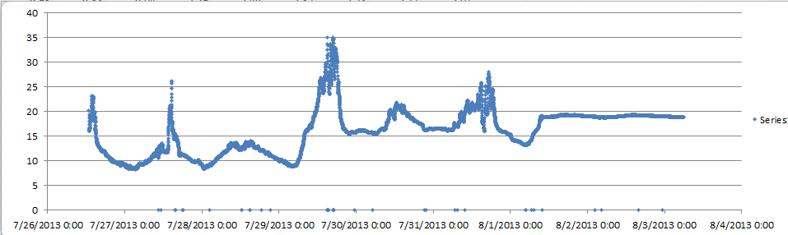

Depth 1 – does not have same abnormalities as depth 0 but has 9 random points at ~5-7 degrees scattered throughout – these are associated with NA values in sensors above and below – removed these abnormalities
Depth 2,3,4,5,6,7 ,8 all ok
Depth 9-17 , – ~12-15 outliers removed (most were same times for all depths)
Depth18,19 – ~15 outliers removed (same time points for both depths)

PAR data
Data is from Woodruff airport located near Trout Lake – no on lake PAR data
Downloaded from LTER High Resolution Meterological Data on 2/29/16
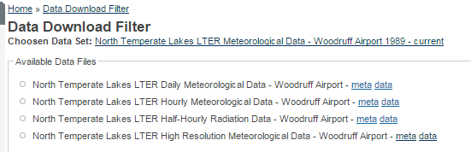
Checked min and max and graphed to look for abnormalities. Removed early spring and late fall data to match T data.

